None of this matters but I'll talk about them because I'm proud of each. These are fun stories of different events in my life and external validation on accomplishments is quite nice.

* Youtube Views
* Yelp Elite
* Reddit Gold
* Robinhood Redemption
* Kubernetes Certification
* Networking Certification
* Coinbase Loss

Gaming history and achievements will hopefully be another separate post at a future date.

# **Youtube**

[Brush Me Off - Kitty and Sad Andy](https://www.youtube.com/watch?v=-kON6sd90gw)

[Cautious Clay - Blood Type (Stripped)](https://www.youtube.com/watch?v=48CCoZzDKbY)

I had many Youtube channels, however this one was for posting music. I would post music that wasn't on Youtube yet as well as creating poorly-made lyric videos to songs that did not have lyric videos yet. I have no talent and have never improved at editing my videos however I do have talent for finding incredible underground music and being hip [😎](https://emojipedia.org/smiling-face-with-sunglasses/).

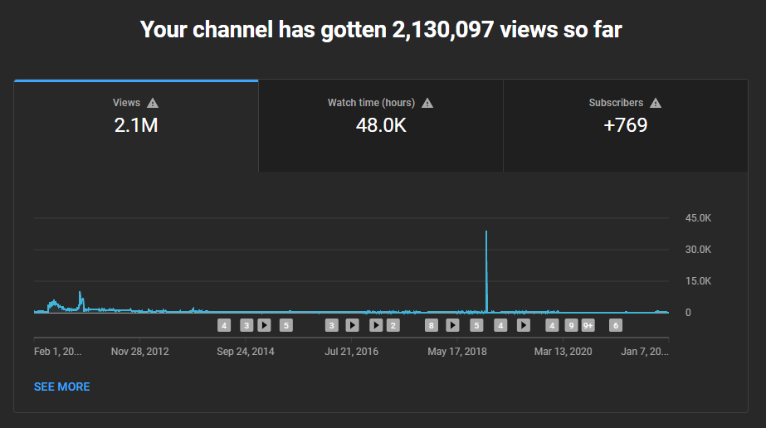

# **Yelp**

<https://yelp.com>

I first became Yelp Elite in 2020. It was completely unexpected.

At that time I had never posted photos and felt like my reviews were incredibly low effort (which they were/are). However I believe my asset was going to quite a number of diverse places, especially ones that were unknown/brand new and that I had plenty of 'friends' from Facebook added on Yelp. Still, I had always heard about Yelp Elite as special and highbrow and was puzzled at my invitation.

Now that I've had Yelp Elite, I am significantly more conscious of reviewing places. Unlike the other accomplishments listed here, this reward from Yelp has significantly influenced my behavior so I understand that they did a proper job choosing to reward me with Yelp Elite and incentivize the future reviews. I now take pictures and actively go to new restaurants that I haven't been to.

This achievement has been a fun rewarding experience. It's also my most sociable award - everyone is familiar with Yelp and enjoys eating food. It's a fun, shared hobby and appreciate the free things and respect/favors when reviewing a restaurant.

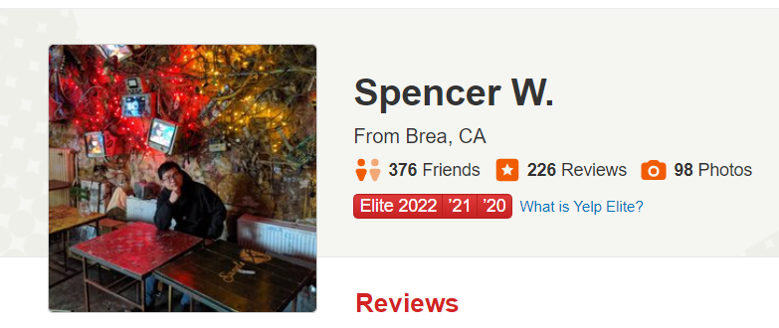

# **Reddit**

<https://reddit.com>

I have never used the Reddit homepage, however I do deeply enjoy reddit and spend time on specific sub-communities. I earned plenty of points (karma) as a significant contributor to [/r/listentothis](https://old.reddit.com/r/listentothis/) in 2012-2016 (before deleting my posts), however I had never received any gold.

Until this post. My first gilding of gold and I'm also proud of my nuanced comment on this AITA thread where I validate the OP's feelings yet invalidate OP's internal guilt towards their idea of the right moral actions to justify the scenario.

I still have never received gold except this one post, but it checks the item off the bucket list and lurking is plenty sufficient for me.

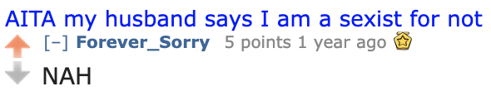

# **Website**

<https://spencers.dev>

I've had various forms of a website. In the beginning I had a blogspot and a personal website I made during High School which my school program (GITA) hosted for the students in our computer program. During this time I created and managed my church youth website. During college I had multiple blogs, including a personal website that my university program (UCSD CSES) hosted. During college I managed my college church website and made sample websites in my courses with Heroku, Wordpress, Wix, and free AWS credits from hackathons.

After college I had a personal website via github static pages with handlebars templating. This evolved into a simple static HTML5 website. My personal website then morphed into blogging with [Jeykll](https://jekyllrb.com/) and ultimately we've evolved into [11ty](https://www.11ty.dev/).

I've always desired to write a book, but that's really a proxy for sharing ideas I find valuable and interesting. After evolving the blog, I've realized somewhere along the way my goals have changed and have already been met. Certainly there are many more articles that are high priority and are in progress, however all-in-all I've progressed through my goal further than I thought possible. Perhaps my former self would be dismayed at this outcome however my present self is extremely content and happy and proud that I've created this blog and instead of writing half-finished articles and keeping them private until perfect and then unveiling them to the world, I've now moved forward by writing something semi-passable and publishing it to the world. And that's great, enjoyable, and commendable..

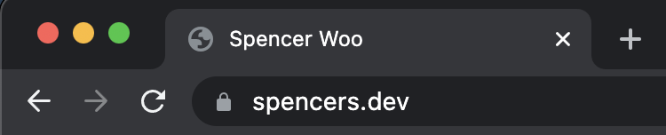

# **Robinhood**

<https://robinhood.com>

I played poker during college and gambled CS:GO skins on the original skin-betting site: csgolounge. After college I got a job and decided to learn about finances. This led to a deep understanding of investments, money, and theory.

I allotted a sensible amount as a boglehead for standard long-term investment plans, however after my baseline was completed my journey into [Options](https://www.investopedia.com/terms/o/option.asp) would begin. I heard about Robinhood in the beginning of their existence and the criticism of their business model but I had no qualms with poor deal flow and simply wanted free commissions to learn.

In the beginning I was extremely successful trading high-margin, high-risk, high-delta options because this was essentially the same as my previous experience with match-betting in CSGO, except options are even more lenient. Yes, people fail because there is a limited time frame, given one can exit anytime before the expiry date, as long as there is high volume, the options safety is loosely correlated to one's attentiveness.

I was up 50% ($10,000 to $15,000) and then I lost it all ($300) because I was more or less all-in for each trade (at this time Robinhood offered zero features to [trade spreads](https://www.investopedia.com/terms/i/ironcondor.asp) so performing them were annoying). After this I took a break because of feeling bad mentally for losing money as well as recharging the mental energy I was using while watching the market zealously. I achieved my goal – I had plenty of experience with Options, understanding market sentiment, timings, and theory (most notably [delta decay](https://www.investopedia.com/terms/c/charm.asp)) and so I took a step back from my gambling obsession.

Over the next year, I slowly made a few trades and the epic story concluded with me taking $300 and making my $10,000 of my original investment back being around net zero. A true comeback story for the ages.



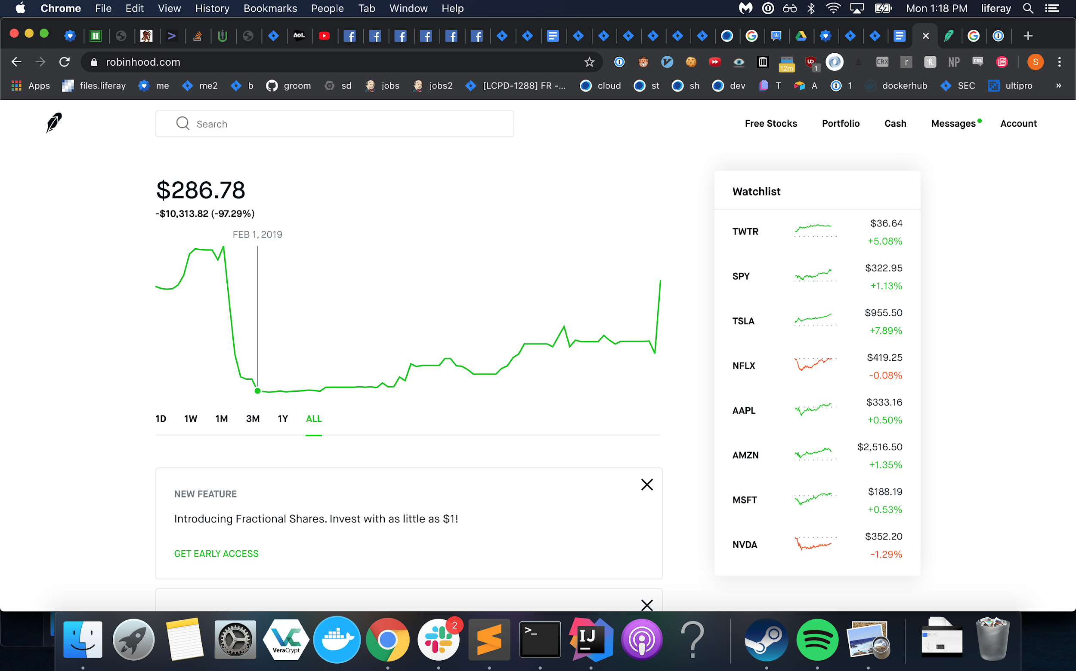

# **Networking Certification**

<https://www.comptia.org/certifications/network>

My first professional certificate. I've done basic security certificates and participated in several events, however this is my first formal certification where you pay and also have to study and take a test. It was a throwback to school and it's an interesting experience. There's such a broad spectrum of knowledge and the [networking-side](https://en.wikipedia.org/wiki/OSI_model) is relevant however the [IT-side](https://en.wikipedia.org/wiki/Category_6_cable) is not relevant to me. It was a fun experience going to a facility to take a test with proctors. During the test I thought I completely bombed but I decided to move forward for experience and I knew that after I failed I had a retake and would be more confident in knowing what to study. Turns out I didn't bomb severely enough and I ended up passing on my first attempt.

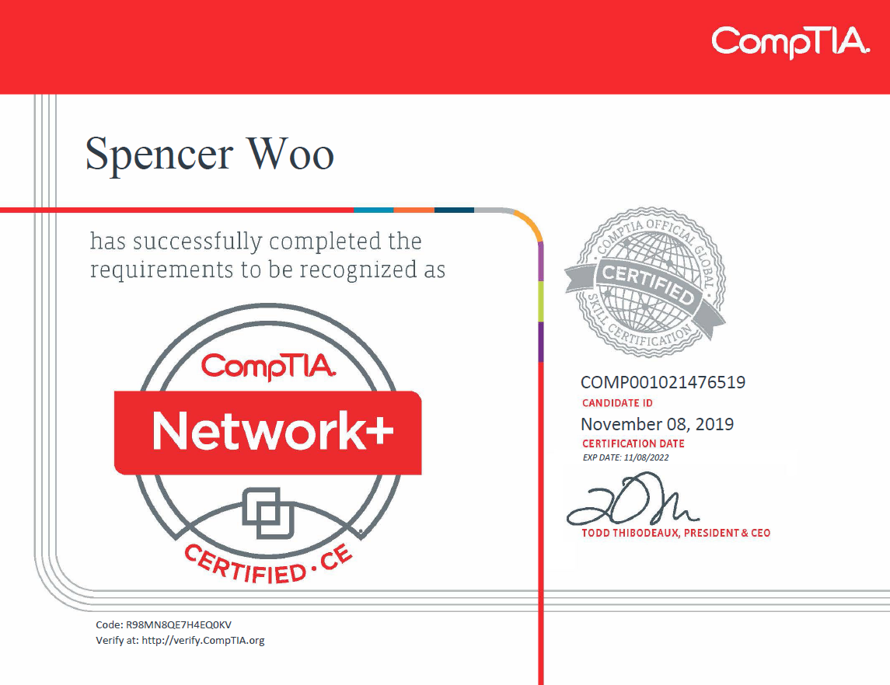

**Kubernetes Certification**

<https://www.cncf.io/certification/ckad/>

This is my most recent certification. This was a more pleasant and relevant certification to my work and I really enjoy having a well-rounded understanding of [Kubernetes](https://kubernetes.io/) architecture and capabilities. I am less a fan of this test than the Network+ test as the speed is a significant factor here as opposed to understanding and design concepts.

They have updated the curriculum – and I am a fan of the new curriculum as it has more depth and practicality with lower level k8s details than before – however it made me uncertain whether my study materials were up-to-date for the new test. My plan was to repeat my Network+ process by taking the test to confirm how to best study firsthand and then use my retake to successfully complete the test as I didn't feel ready at the moment.

However, coming up to the test, I stumbled across great articles giving tips on the CKAD exam and realized that it was a test more about speed than understanding and at that moment I wished I had hammered away at practice problems instead. I felt inadequate and tried to cancel my first attempt to push it back a few days just to familiarize myself with accomplishing tasks quickly, however the test time was too soon to cancel.

I went into the test and immediately my feelings of inadequacy were validated – I fumbled through the first two questions which were incredibly complex and took me forever with several simple mistakes that cost me so much time. The extra pressure of my poor testing environment and the live proctor made me discouraged but I thought to myself, 'practicing problems is what I'll do anyways' so I persisted and decided practicing here is just as good as practicing on my own which I'll need to do in the future anyways.

However, as the test went on, I ended up running through all the questions and realized I had half my time left – I felt better as perhaps it seemed doable now as my hardest questions seemed to be the first two that I had so much difficulty with. I went back and filled in the questions I had passed through quickly and verified/corrected tons of mistakes I had made.

In the end, I thought I failed but I wasn't too far off and knew exactly how to study for my retake. However, in the exact same fate as Network+, I ended up passing on my first preliminary attempt and not needing to retake the test.

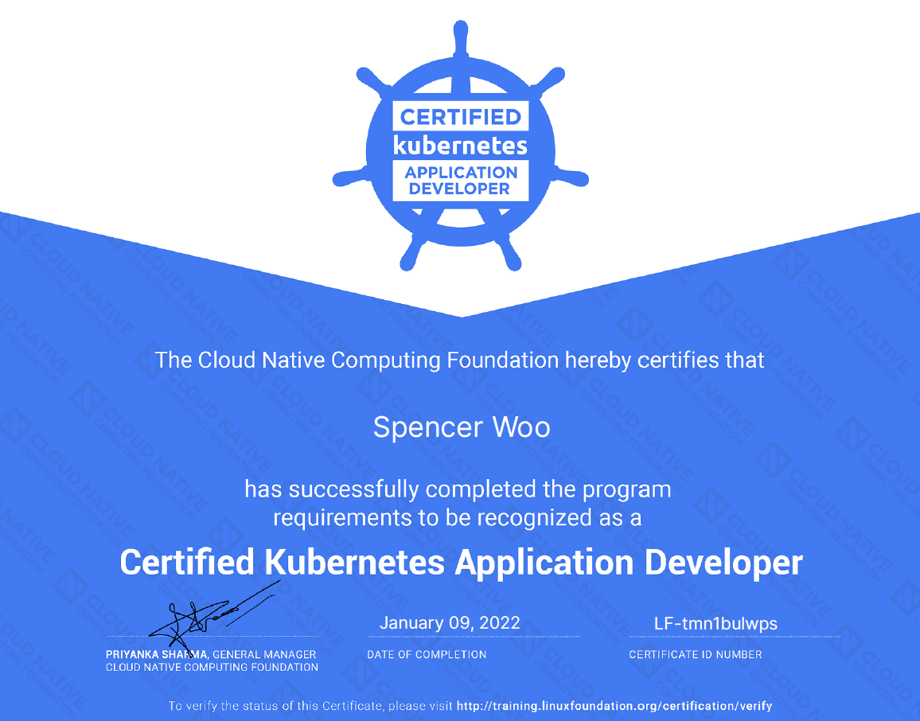

# **Coinbase**

<https://www.coinbase.com/>

In the beginning, Coinbase reached out to university students – specifically Computer Science majors – and offered them $10 to sign up and even more for referrals.

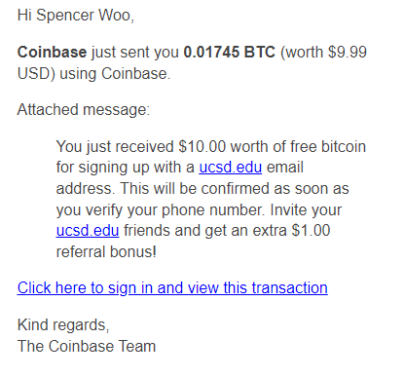

Long story short, I ended up forgetting about this account until [Bitcoin surged](https://www.investopedia.com/articles/forex/121815/bitcoins-price-history.asp) into hyper-mainstream popularity. I then decided to check and saw that my bitcoin had been transferred to another account with the message "gg". It's pretty hilarious.

# **Video Game**

During my High School years I was in a computer science program. In our Junior Year we worked with Flash, specifically what is known as ActionScript 3. It was an incredibly fun year and I was deeply influenced by Warcraft 3 Custom Games and loved the Tower Defense genre.

During the class I created GITA Tower Defense. It has poor quality of life, but overall it's a fun experience and I'm happy I created the game and published it.

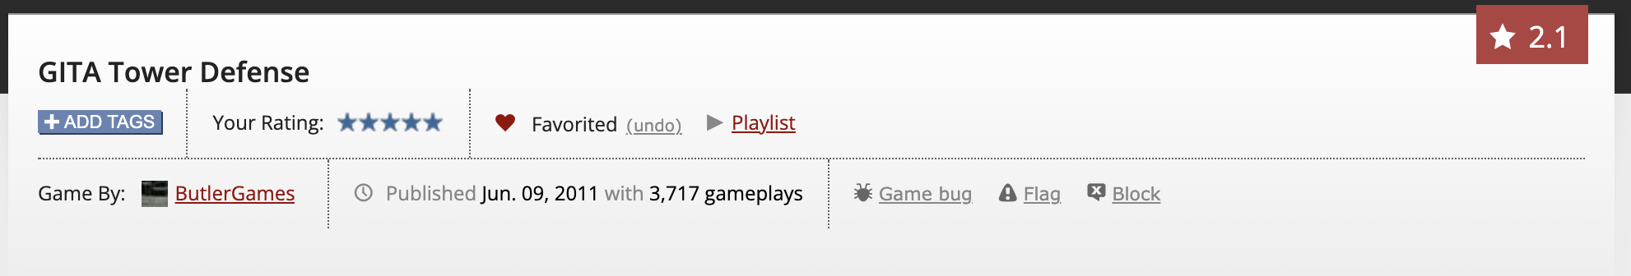

# 

# **Progression**

I think if you're fortunate you're a different person every five years.

Perhaps that's naive and I only hold that sentiment because I'm in my twenties. However, I'm not convinced that stagnation and consistency is inherently a virtue. I suppose like all things there can be too much or too little – deficiency or excess. The chaotic person wants stability and the stable person wants adventure.

Personally, I feel like my self-improvement project will never run out – even when I'm considering a timeline of the next fifty years. I do agree change is harder as more foundational layers have been constructed and models generated – ["Why we shouldn't learn new things"](http://google.com).

**Slow**

Progression is incredibly slow – a marathon not a sprint. And that is probably even an understatement.

The changes in my life have always been imperceptibly slow – until one day you turn around and realize you've walked thousands of miles and have ascended the mountain.

What does it mean to change? I have tried to change my language [Language Modifications](https://spencers.dev/posts/blog/2021-09-25-language-modifications/) however success is not eliminating my old behavior, but rather progress. Every 100 times I would use a certain word, or exhibit a certain behavior, and now perhaps it's 80 out of 100 times. I fail/regress/mistake repeatedly but progress leads to transformation.

Aside from social behavior and ideology, one functional change I have made is with my driving behavior. I would not have thought it possible however I am incredibly proud of myself for reducing my ego and driving safer, patient, and more charitably. A more commendable way to drive.

**Acknowledgement**

When we change ourselves with intentionality, it is because we believe our changed version is better than our former version. Changing is hard work, and often afterwards the change feels so obvious, substantial, and blatant.

However, paradoxically, this blatant change often goes unnoticed by others. For example, I'm certain almost every one of my friends have changed substantially from high school yet when reconnecting it isn't very apparent. Perhaps it's because we fall into similar patterns or conversations as when we were close, however perhaps change is more subtle.

I often want people to remark how much I've changed. Partially because I don't want to associate with my past self.

Perhaps the worst offense is not when one does not notice the change but rather the change is invalidated and disregarded. For instance, if one has been confronted about their problematic anger behavior and they have worked incredibly hard to address it. It can be tragic when the behavior inevitably resurfaces.

At the end of the day, coming to peace without connecting the dots and acknowledging is part of the process.

**Accomplishments**

External validation isn't inherently problematic and can be quite a healthy motivator.

We Always Were Suckers for Ridiculous Hats

<https://www.youtube.com/watch?v=XscJd4j7JH8>

Far Caspian - Following the Trend